" Fill in the grid so that every row,
every column, and every 3x3 box
contains the digits 1 through 9. "
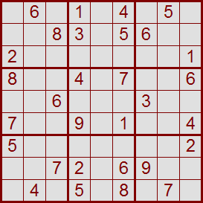Roll your mouse on and off the grid.
You may have to wait for the page to load fully.
Check for products which rely on Sudoku Puzzles by Pappocom
